

Student Name……………………………………

MATHEMATICAL METHODS UNITS 3 & 4

TRIAL EXAMINATION 2

2018

Reading Time: 15 minutes
Writing time: 2 hours

Instructions to students
This exam consists of Section A and Section B.
Section A consists of 20 multiple-choice questions, which should be answered on the detachable answer sheet which can be found on page 24 of this exam.
Section B consists of 4 extended-answer questions.
Section A begins on page 2 of this exam and is worth 20 marks.
Section B begins on page 9 of this exam and is worth 60 marks.
There is a total of 80 marks available.
All questions in Section A and Section B should be answered.
In Section B, where more than one mark is allocated to a question, appropriate working must be shown.
Where a numerical answer is required, an exact value must be given unless otherwise directed.
Diagrams in this exam are not to scale except where otherwise stated.
Students may bring one bound reference into the exam.
Students may bring into the exam one approved technology (calculator or software) and, if desired, one scientific calculator. Calculator memory does not need to be cleared. For approved computer-based CAS, full functionality may be used.
A formula sheet can be found on pages 22 and 23 of this exam.

This paper has been prepared independently of the Victorian Curriculum and Assessment Authority to provide additional exam preparation for students. Although references have been reproduced with permission of the Victorian Curriculum and Assessment Authority, the publication is in no way connected with or endorsed by the Victorian Curriculum and Assessment Authority.

© THE HEFFERNAN GROUP 2018
This Trial Exam is licensed on a non transferable basis to the purchasing school. It may be copied by the school which has purchased it. This license does not permit distribution or copying of this Trial Exam by any other party.
SECTION A – Multiple-choice questions

Question 1

Let 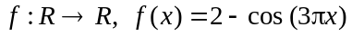.
The period and range of this function are respectively

- 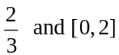
- 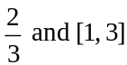
- 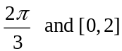
- 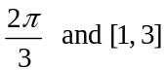
- 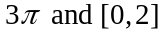

Question 2

The maximal domain of the function 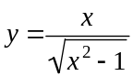 is

- R
- 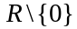
- 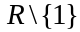
- 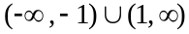
- 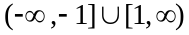

Question 3

For 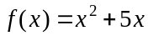, the average rate of change with respect to x for the interval 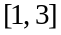 is

- 6
- 9
- 12
- 21
- 24

Question 4

The simultaneous linear equations 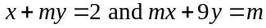 will have a unique solution only for

- 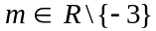
- 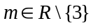
- 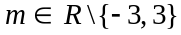

Question 5

A bucket contains six green balls and eight yellow balls.
Three balls are taken at random from the bucket without replacement.
The probability that the balls are not all the same colour is

- 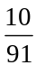
- 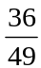
- 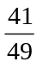
- 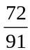
- 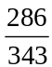

Question 6

The graph of the function 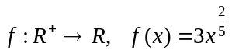 is reflected in the x-axis, then dilated by a factor of two from the x-axis and then translated four units to the left.
Which one of the following is the rule for this transformed graph?

- 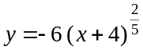
- 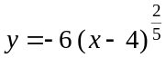
- 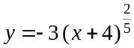
- 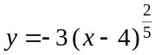
- 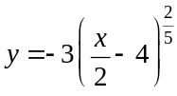

Question 7

The inverse function of , is given by

- 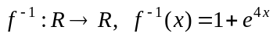
- 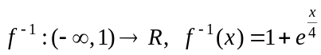
- 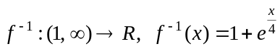
- 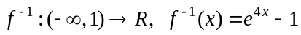
- 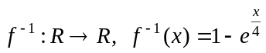

Question 8

An energy company takes a large sample of its customers. The 95% confidence interval for the proportion of these customers who pay their bills on the due date is found to be (0.275, 0.395).
For this interval, the sample proportion is

- 0.060
- 0.196
- 0.335
- 0.426
- 0.670

Question 9

The equation 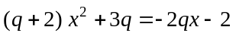 has no real roots when

- 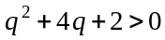
- 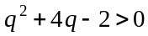
- 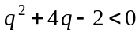
- 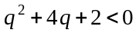
- 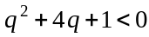

Question 10

The continuous random variable X, has a normal distribution with mean 15 and standard deviation 3.
The continuous random variable Z has the standard normal distribution.
The probability that Z is between – 1 and 3 is equal to

- 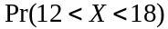
- 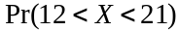
- 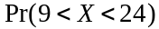
- 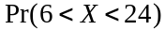
- 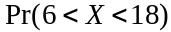

Question 11

The transformation defined by 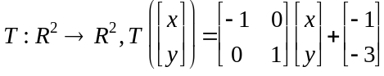 maps the graph of 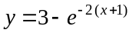 onto the graph of

- 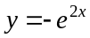
- 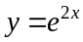
- 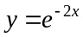
- 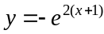
- 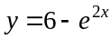

Question 12

Part of the graph of a function f is shown below.
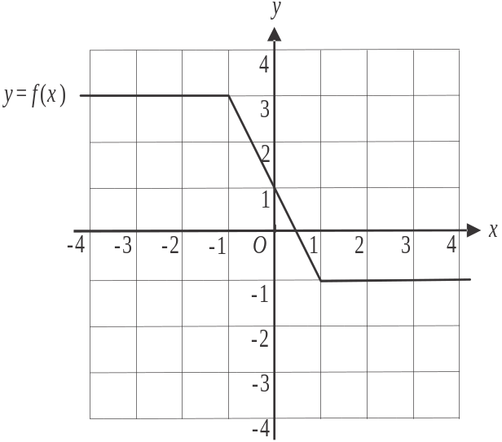

The average value of this function f over the interval 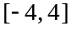 is
- 0
- 1
- 1.5
- 1.75
- 2

Question 13

Let 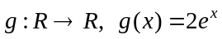. Which one of the statements below is not true for all ?

- 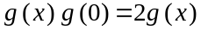
- 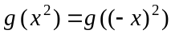
- 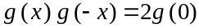
- 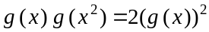
- 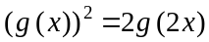

Question 14

The probability distribution for the discrete random variable X is shown below.

X | −1 | 0 | 2
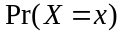 |  | a
The mean of X is 0.6.
The variance of X is

- 0.24
- 0.36
- 2.04
- 2.14
- 2.4
Question 15

The graph of the cubic function f passes through the point 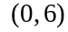.
The graph of its derivative function 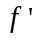 passes through the point 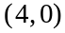 and has its turning point at 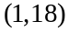.
The rule for f is

- 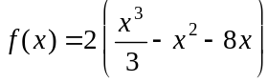
- 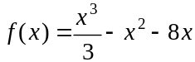
- 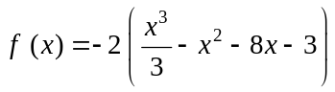
- 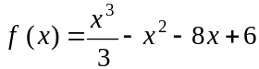
- 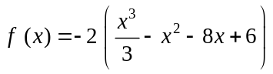

Question 16

For samples of six Victorian tertiary students, is the random variable representing the proportion who live at home.
If 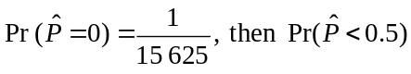 is closest to
- 0.017
- 0.099
- 0.181
- 0.901
- 0.983

Question 17

Leo plays a game of chance where his probability of winning each game is 0.25. The probability of him winning one game is independent of winning any other game.
If the probability of Leo winning at least one game is greater than 0.85, then the least number of games, n, that he needs to play is closest to

- 6
- 7
- 9
- 12
- 13
Question 18

The area under the graph of 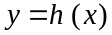 between is 12 square units. The value of h over this interval is greater than zero.
The area, in square units, under the graph of 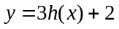 over this same interval is

- 30
- 38
- 40
- 42
- 50

Question 19

For the function f, 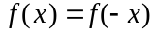.
The graph of f has x-intercepts located at 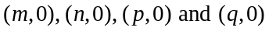 as shown below.
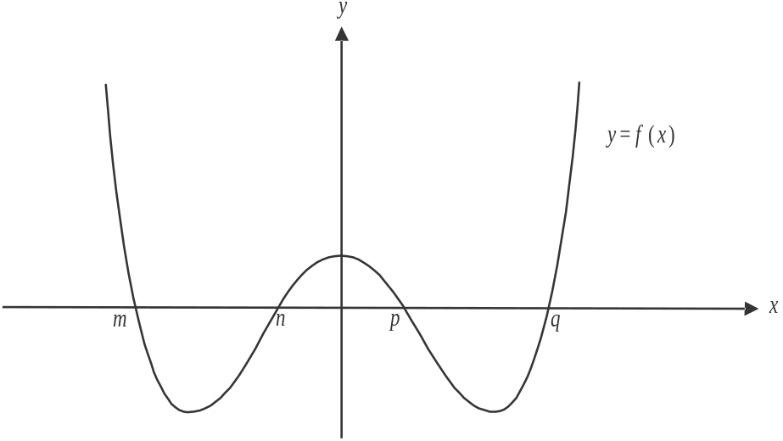

The total area of the regions bounded by the graph of f and the x-axis between 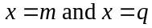 is

- 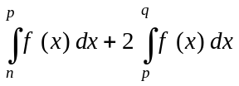
- 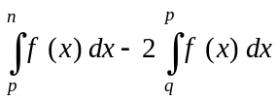
- 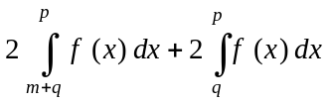
- 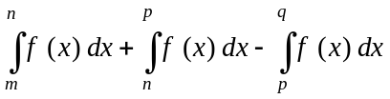
- 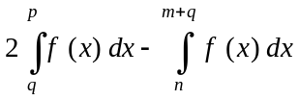
Question 20

For the trapezium PQRS, the length of PQ is u, the length of PS is u and the angle PST is .
Also, the length of RT is 3u as shown below.

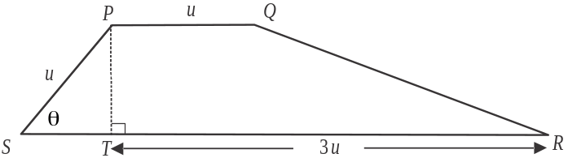

The area of the trapezium is a maximum when the value of 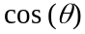 is

- 1

- 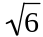

- 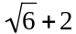

- 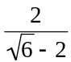

- 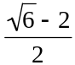
SECTION B

Answer all questions in this section.

Question 1 (12 marks)

Let 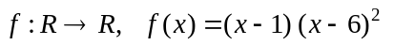.
The graph below shows part of the graph of f.
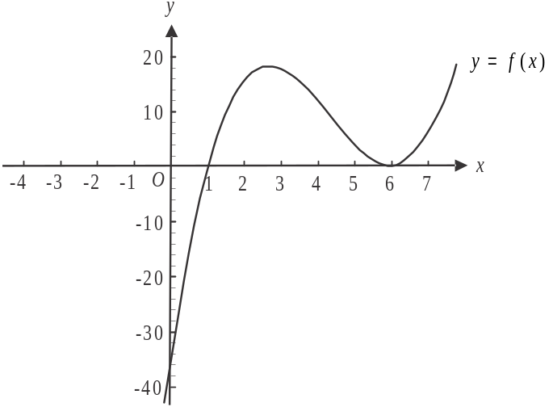

- Find the coordinates of the stationary points. 2 marks

- Find the values of x for which 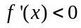. 1 mark

- Show that the midpoint of the line segment joining the two stationary points found in part a. lies on the graph of 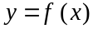. 2 marks

Let .

- i. Find, in terms of a, the gradient of the graph of g at the point 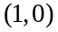. 1 mark

  - For what values of a is the gradient of the graph of g at the point positive? 1 mark

- The point 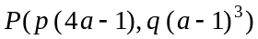, where p and q are rational numbers, lies on the graph of g. The gradient of the graph of g at the point P and at the point is equal.
Find the values of p and q. 2 marks

- A graph of g for which is shown below.
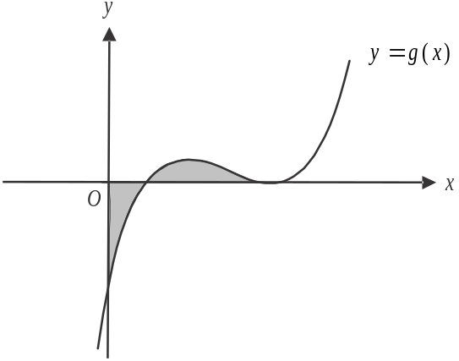

Find the value of a for which the shaded region above the x-axis has the same area as the shaded region below the x-axis. 3 marks

Question 2 (16 marks)

A windmill has a tower of height ten metres and blades of length three metres. These blades rotate anticlockwise about point M which is at the top of the tower. A vertical pipe of length ten metres runs from point O on the ground to point M.
One of the blades has the manufacturer’s logo on its tip as indicated by point L on the diagram below.
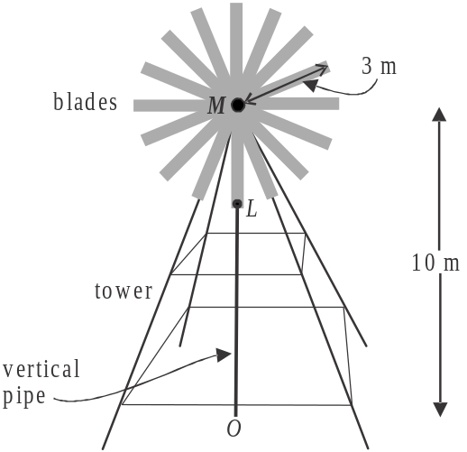

One particular day, the breeze moves the blades of the windmill so that the height h, in metres, of point L above the ground is given by 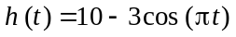 where t is the time, in minutes, after the movement was first observed.

- What was the initial height of L above the ground. 1 mark

- After how many minutes is L next at this height above the ground? 1 mark

- What is the average rate of change of the height of L above the ground between ? 2 marks

- Find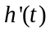 and hence find the least value of t for which the rate of change of h is a maximum. 2 marks

Water is to be pumped from point 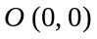 on the ground, up the vertical pipe to point 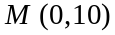 and then along a straight downpipe of length ten metres to point 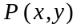 where it is to enter a cylindrical tank through an opening on its top edge.
Point P lies on the graph of 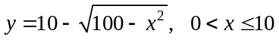 as indicated on the graph below.

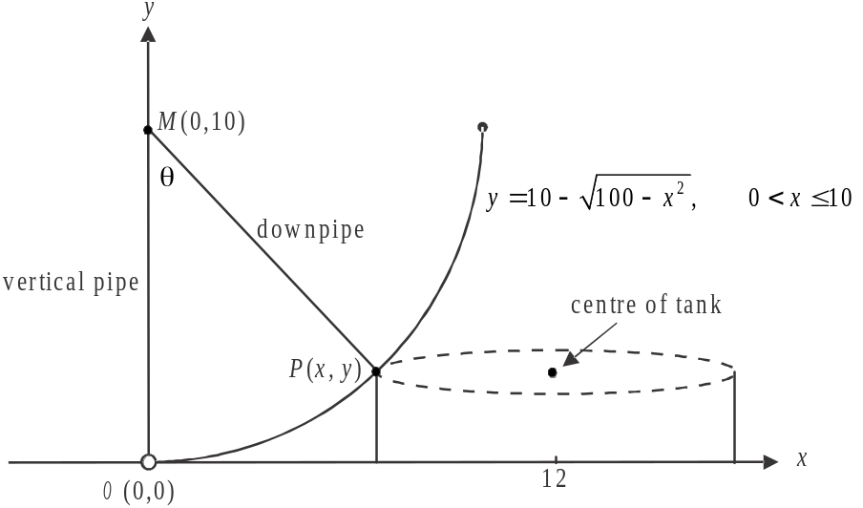

The tank is to be built with its centre positioned 12 metres from the vertical pipe.
The vertical pipe makes an angle of with the downpipe, that is, angle 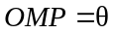.

- Show that the volume V, in cubic metres, of the tank is given by
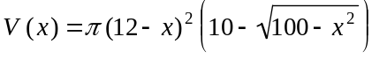. 1 mark

- Write down the domain of V. 1 mark

g. On the axes below, sketch the graph of V against x. Label any endpoints with their exact
coordinates and any stationary points with their coordinates expressed correct to one decimal
place. 3 marks

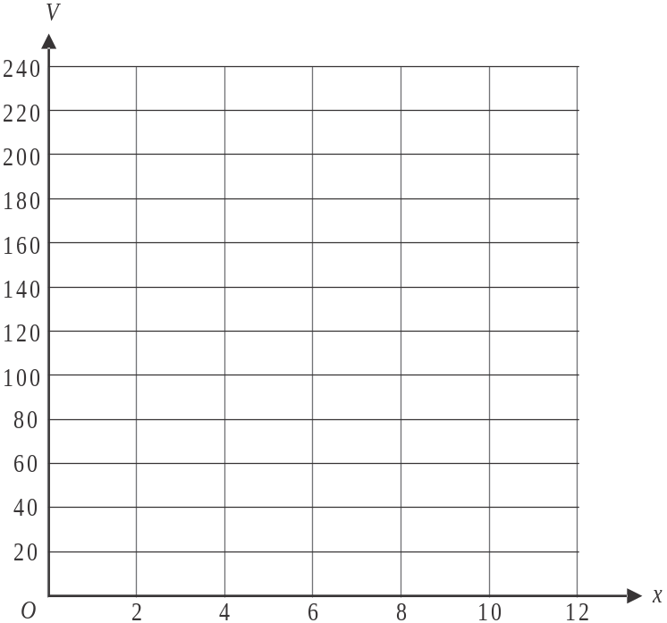

h. Hence find the radius of the tank when its volume is a maximum, correct to two decimal
places. 1 mark

i. Find the angle , in degrees, correct to two decimal places, when the volume of the tank is a
maximum. 2 marks

j. Hence find the time taken, in minutes correct to two decimal places, for the blade with the
logo marked on it at L, to move from its starting position to the position where it is parallel
to the downpipe represented by MP. 2 marks

Question 3 (17 marks)

A manufacturer has a large stockpile of model X mobile phones and of model Y mobile phones at its warehouse.
The time it takes for a mobile phone to increase its battery charge from zero to fully charged is called its charge-time. All the phones at the warehouse have zero charge.

The charge-time for model X phones is normally distributed with a mean of one hour and a standard deviation of three minutes.

- Find the probability that a model X phone that has been randomly selected from the stockpile has a charge-time greater than 62 minutes, correct to four decimal places. 1 mark

  - A second model X phone is randomly selected from the stockpile. After one hour of charging it is still not fully charged. Find the probability that this phone will be fully charged sometime after 65 minutes, correct to four decimal places. 2 marks

  - A further three model X phones are randomly selected from the stockpile.
Find the probability that exactly one of these three phones has a charge time greater than one hour. 2 marks

It is known that 10% of the model Y mobile phones that the manufacturer has in its stockpile have a charge-time greater than one hour.

- A large consignment of model Y phones is sent to a retail outlet which sells 32 of them on the first day they arrive. Find the probability, correct to four decimal places, that at least one of these phones sold on the first day has a charge-time greater than one hour. 2 marks

The manufacturer decides to take samples of 100 model Y phones from a number of different retail outlets that it has supplied.
Let be the random variable of the distribution of sample proportions of model Y phones with a charge-time greater than one hour for these samples of 100 model Y phones.

- Find the expected value and variance of . 2 marks

- Find 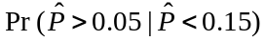. Give your answer correct to four decimal places. Do not use a normal approximation. 3 marks

- For a particular retail outlet, the sample of 100 model Y phones taken is found to contain 12 phones which have a charge-time of greater than one hour.
Use this sample to determine a 90% confidence interval, correct to two decimal places, for the population proportion of model Y phones that have a charge-time of greater than one hour. 1 mark

Model X and model Y phones are identical except for their exterior packaging and the charge-time of their batteries.
There are equal numbers of model X and model Y phones in the stockpiles at the warehouse.
One day a phone is found without its exterior packaging.
A technician decides that if the charge time of the phone is greater than one hour it will be repackaged as a model X phone, otherwise it will be repackaged as a model Y phone.

- Find the probability that the phone is repackaged correctly. 2 marks

- Find the probability that the phone was repackaged as a model Y phone given that the phone was repackaged correctly. 2 marks

Question 4 (15 marks)
Let 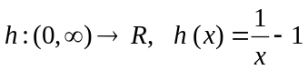.
The graphs of h and its inverse 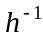 are shown on the graph below.
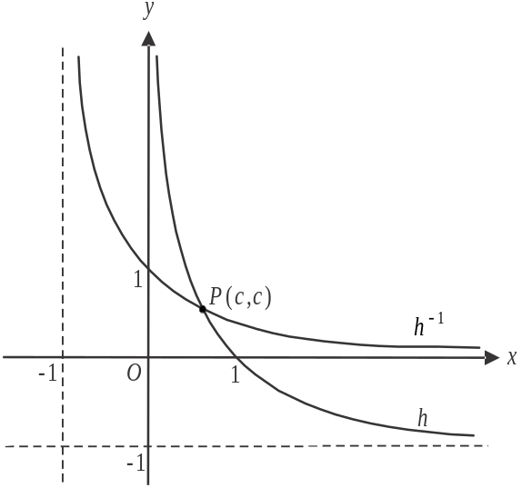

The graphs intersect at the point 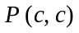.

- Find the rule and domain of . 2 marks

- i. Find the value of c. 1 mark

- Find 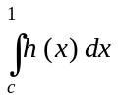. 1 mark

- Hence find the area of the region bounded by the graphs of h and and the x and y axes. 2 marks

Let 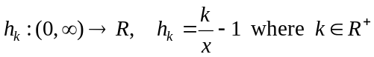.

The transformation 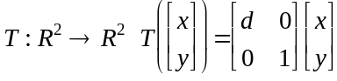 maps the graph of h onto the graph of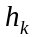.

- i. Express d in terms of k. 1 mark

- Describe, in terms of k, the transformation defined by T. 1 mark

The graphs of and its inverse 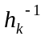 are shown below.
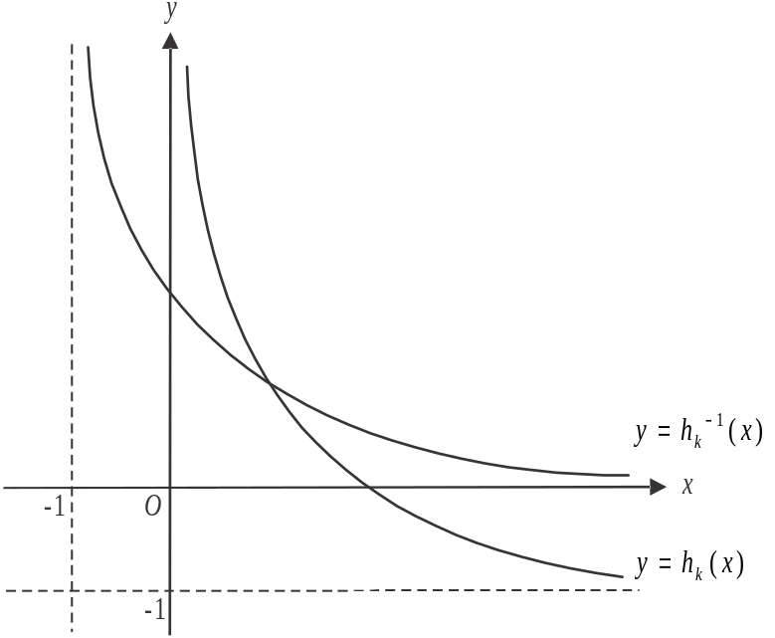

- Show that the rule for is given by 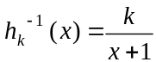. 1 mark

The line is the tangent to the graph of at the point where it crosses the x-axis.
The line 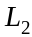 is the tangent to the graph of at the point where it crosses the y-axis.

- Show that when 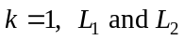 represent the same line. 2 marks

Let be the acute angle made by and the x-axis.
Let be the acute angle made by and the x-axis.

- Find the values of k for which . 2 marks

Let 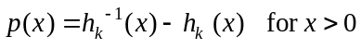.

- i. Find, in terms of k, the values of x for which 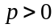. 1 mark

  - Write down a definite integral involving p that gives the area enclosed by the graphs of 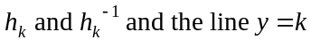. 1 mark

Mathematical Methods formulas

Mensuration
area of a trapezium | 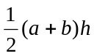 | volume of a pyramid | 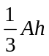
curved surface area of a cylinder | 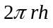 | volume of a sphere | 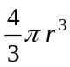
volume of a cylinder | 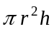 | area of a triangle | 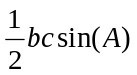
volume of a cone | 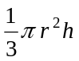

Calculus
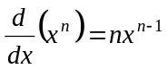 |  | 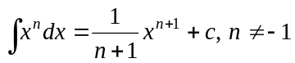
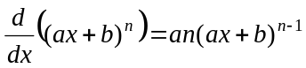 |  | 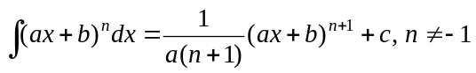
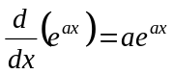 |  | 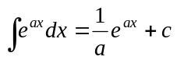
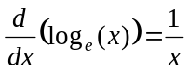 |  | 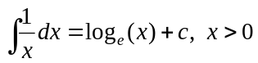
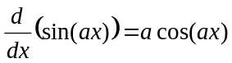 |  | 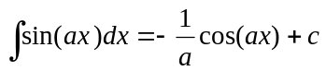
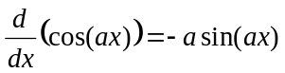 |  | 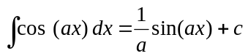
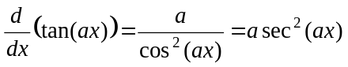
product rule | 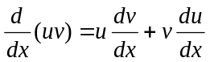 | quotient rule | 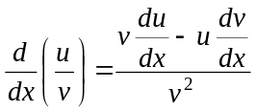
chain rule | 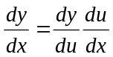
Mathematics Formula Sheets reproduced by permission; © VCAA 2017. The VCAA does not endorse or make any warranties regarding this study resource. Current and past VCAA VCE® exams and related content can be accessed directly at www.vcaa.vic.edu.au
Probability

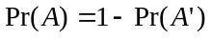
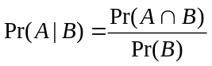
mean | 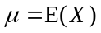 | variance

Probability distribution |  | Mean | Variance
discrete | 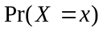=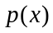 | 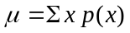 | 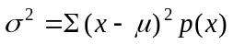
continuous | 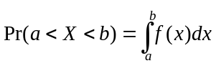 | 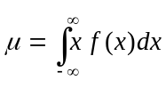 | 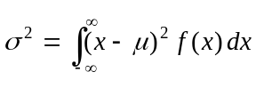

Sample proportions

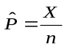 |  | mean | 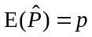
standard  deviation | 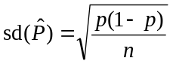 | approximate  confidence  interval | 